Lab Exercise – Create and Mount Amazon S3 Files on EC2
Lab Objective
In this lab, you will:
- Create an S3 bucket
- Create an Amazon S3 Files file share
- Create an EC2 instance
- Configure the required Security Groups
- Create and attach an IAM role
- Mount Amazon S3 Files on EC2
- Create folders and files
- Delete folders and files
- Validate all operations

Lab Architecture
AWS Cloud
+-----------------------------------------------------------+

Amazon S3 Bucket
demo-bucket-<yourname>

│
│
Amazon S3 Files
(Managed File Share)

│
NFS (TCP 2049)

│
+----------------------------+
| EC2 Instance |
| Amazon Linux 2023 |
| |
| /mnt/s3files |
+----------------------------+

+-----------------------------------------------------------+

Prerequisites
- AWS Account
- AWS CLI configured
- Existing VPC
- Internet Gateway
- Key Pair

Lab 1 – Create an S3 Bucket
- Open AWS Console
- Navigate to Amazon S3
- Click Create bucket
Configure:
Setting | Value
Bucket Name | demo-bucket-lab-001
Region | Same region as EC2
Object Ownership | Bucket owner enforced
Block Public Access | Enabled
Click Create bucket.
Validation
The bucket status should be Available.
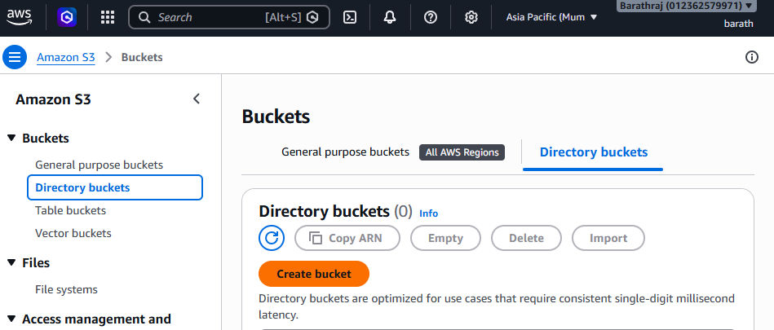
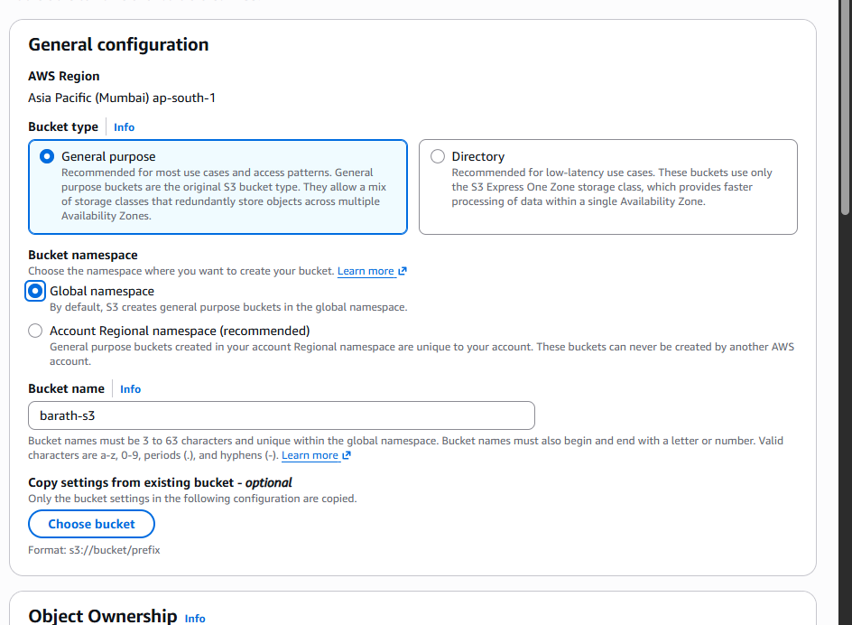
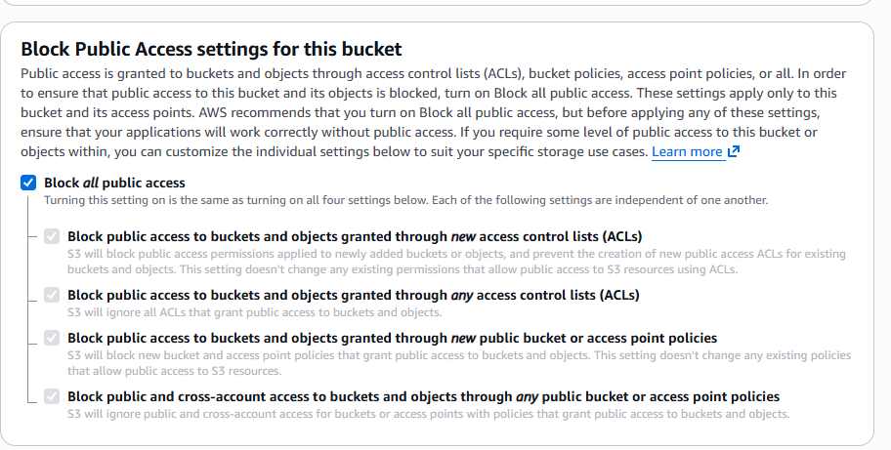

Lab 2 – Create an IAM Role for EC2
Go to:
IAM → Roles → Create role
Trusted entity:
- AWS Service
- EC2
Attach these AWS managed policies:
- AmazonS3FilesClientFullAccess
- AmazonS3FilesClientReadWriteAccess
- AmazonS3FullAccess
(Optional: use a custom least-privilege S3 policy instead of AmazonS3FullAccess for production.)
Role name:
EC2-S3Files-Role
Create the role.
Validation
The role is listed with all three policies attached.
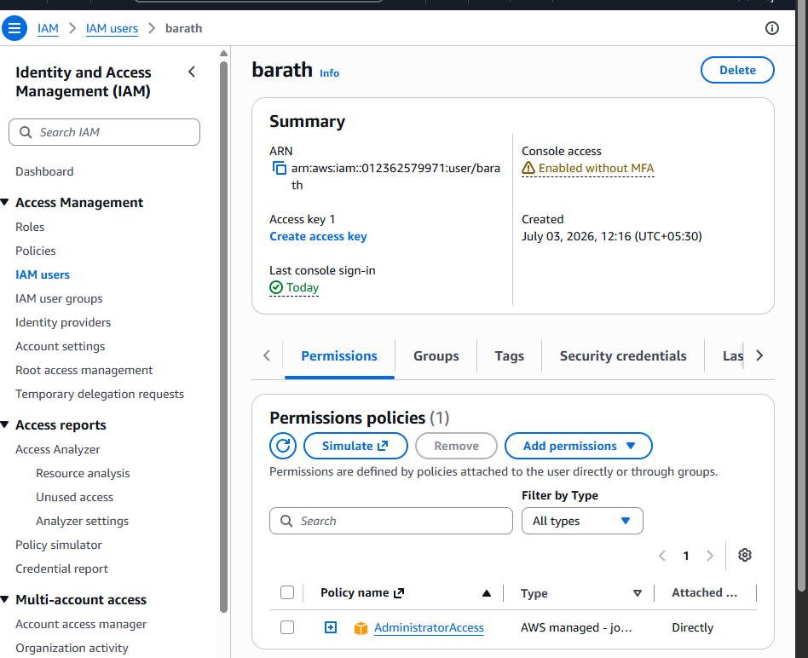
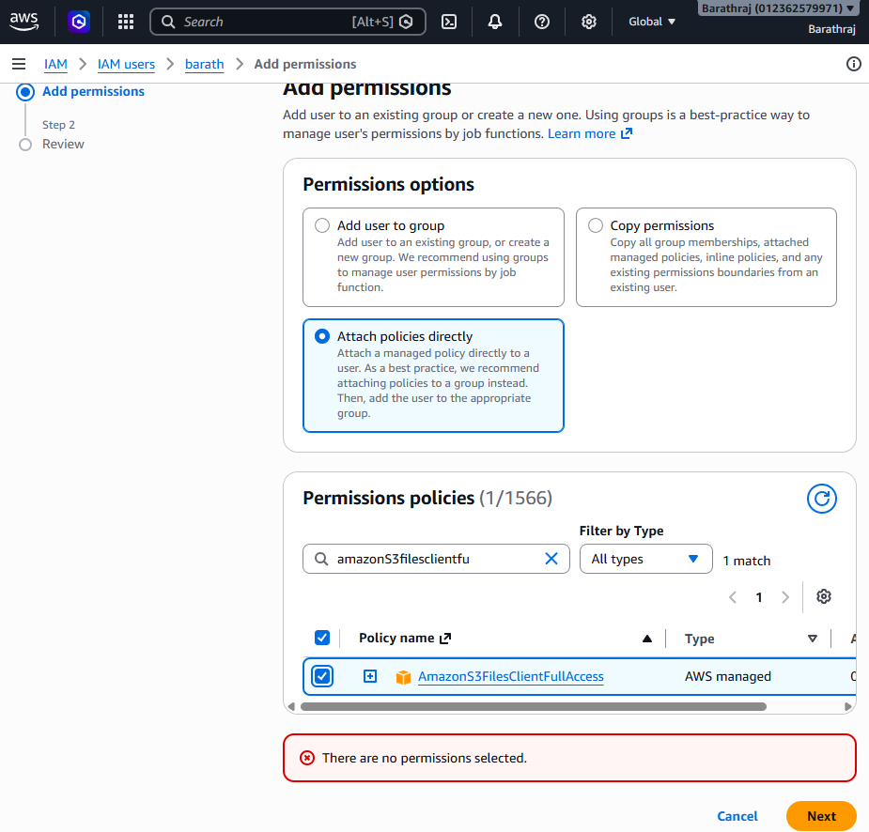
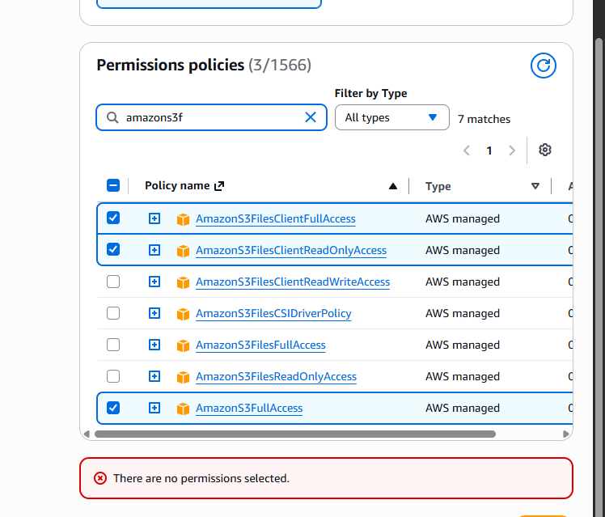
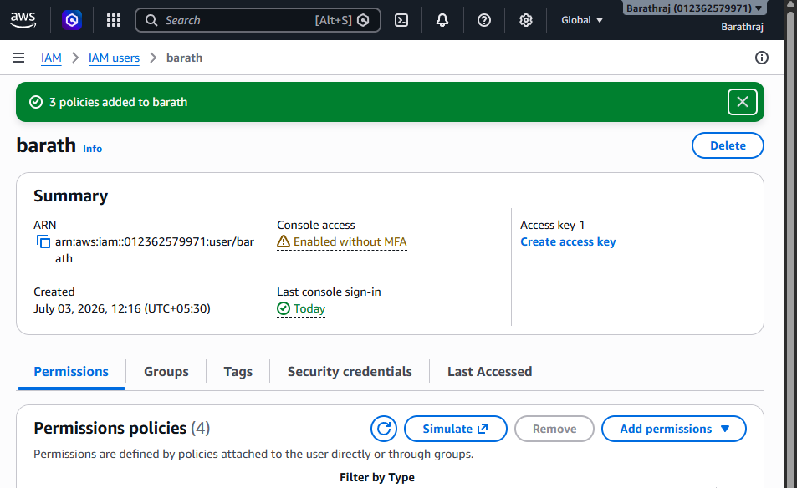

Lab 3 – Create a Security Group for EC2
Create a security group named:
EC2-S3Files-SG
Inbound Rules
Type | Protocol | Port | Source
SSH | TCP | 22 | My IP
Outbound Rules
Type | Protocol | Port | Destination
HTTPS | TCP | 443 | 0.0.0.0/0
NFS | TCP | 2049 | S3 Files Security Group (or VPC CIDR if required)
Save the security group.

Lab 4 – Create a Security Group for Amazon S3 Files
Create another security group:
S3Files-SG
Inbound Rules
Type | Protocol | Port | Source
NFS | TCP | 2049 | EC2-S3Files-SG
Outbound Rules
Allow All (default).
Validation
The security group is created successfully.
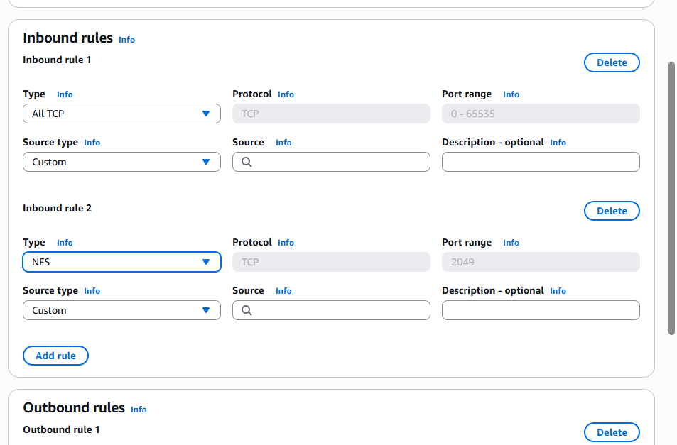
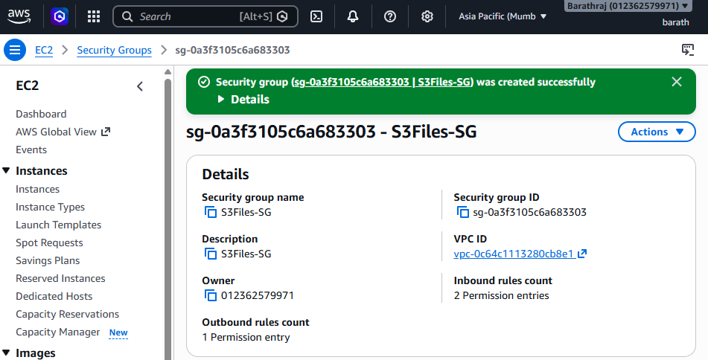

Lab 5 – Launch EC2 Instance
Launch a new EC2 instance.
Configuration:
Setting | Value
AMI | Amazon Linux 2023
Instance Type | t3.small
Key Pair | Existing Key Pair
IAM Role | EC2-S3Files-Role
Security Group | EC2-S3Files-SG
Storage | 20 GB gp3
Launch the instance.
Validation
- Instance state = Running
- Both status checks pass.
- SSH login succeeds.
- 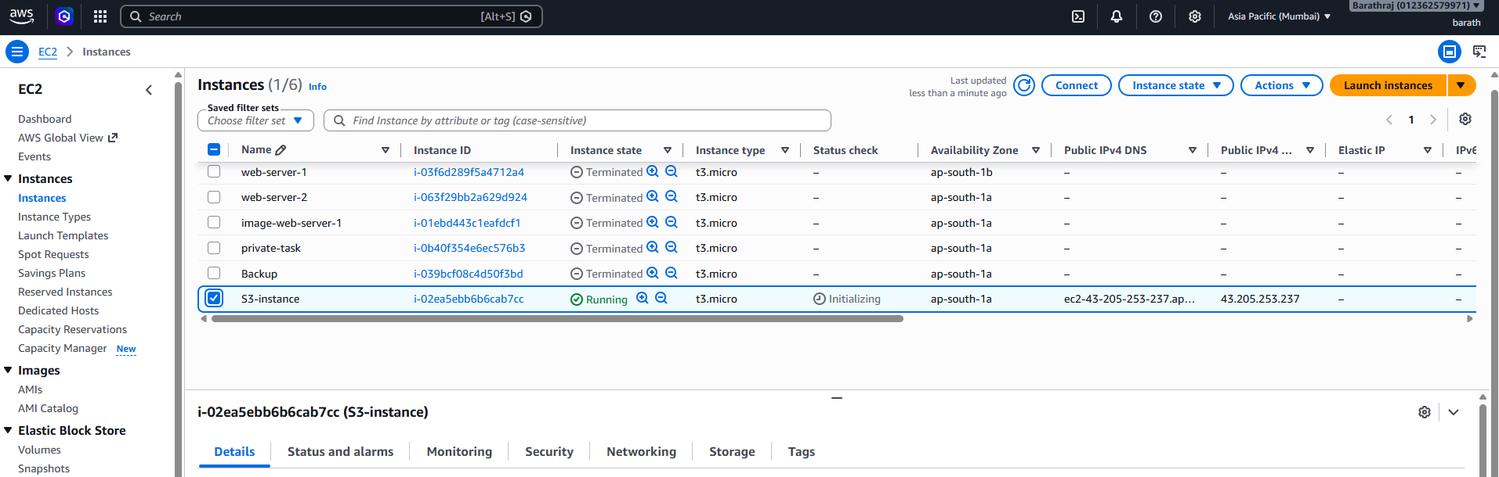

Lab 6 – Create Amazon S3 Files File Share
Open:
Amazon S3 → Files
Click Create file share.
Configure:
Setting | Value
File Share Name | lab-s3files
S3 Bucket | demo-bucket-lab-001
Access Mode | ReadWrite
VPC | Same VPC as EC2
Subnet | Same subnet/AZ as EC2
Security Group | S3Files-SG
Create the file share.
Validation
Status:
Available
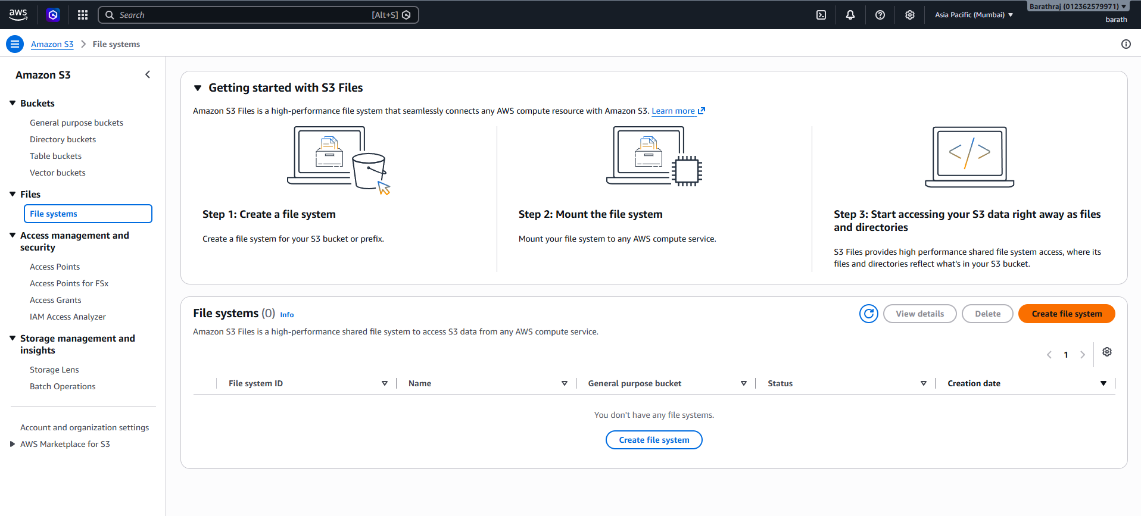
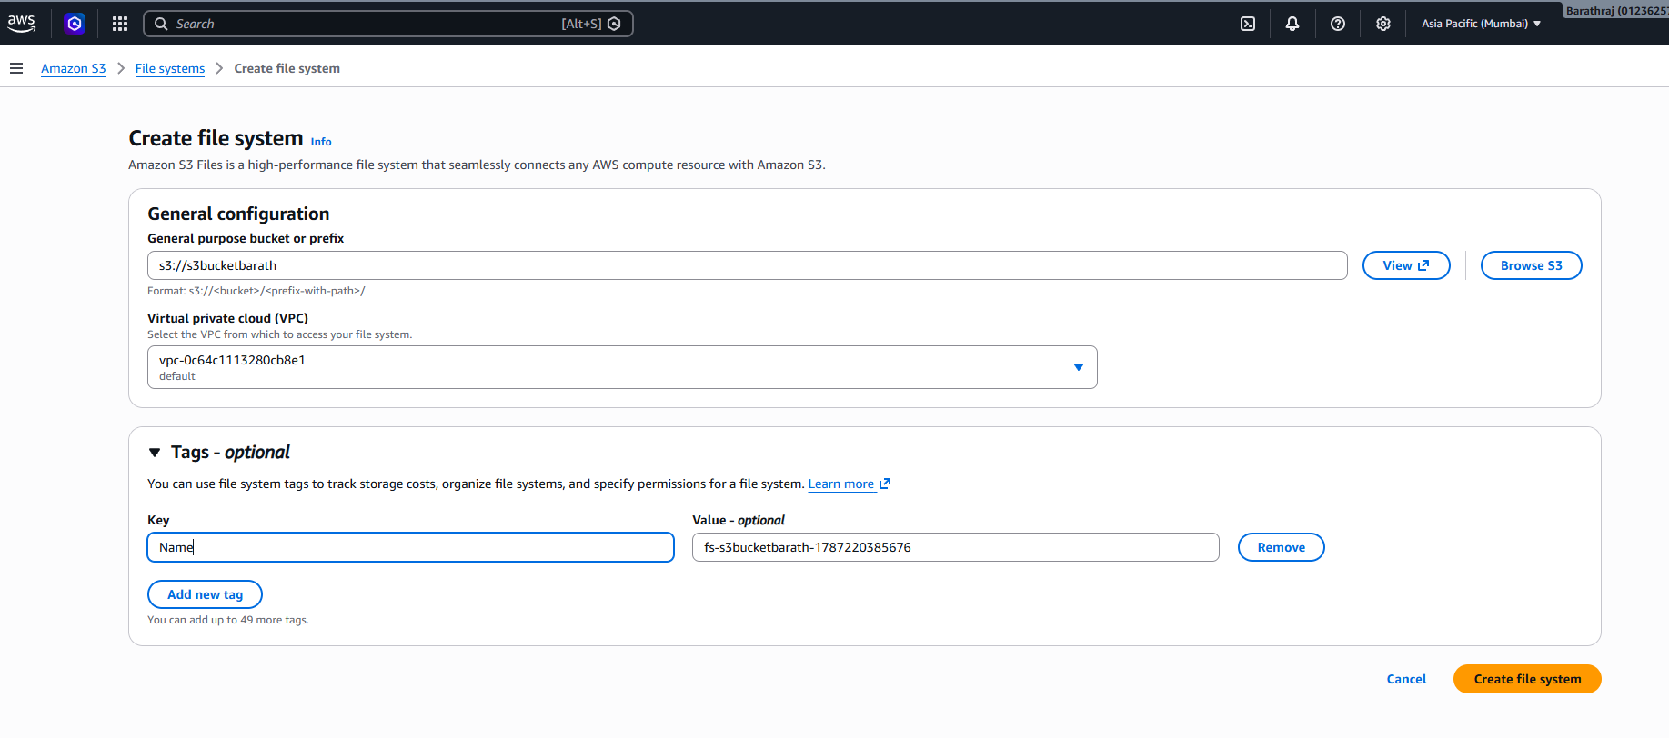

Lab 7 – Connect to EC2
ssh -i lab.pem ec2-user@<EC2-Public-IP>
Confirm the IAM role:
aws sts get-caller-identity
Validation
The role ARN is displayed.
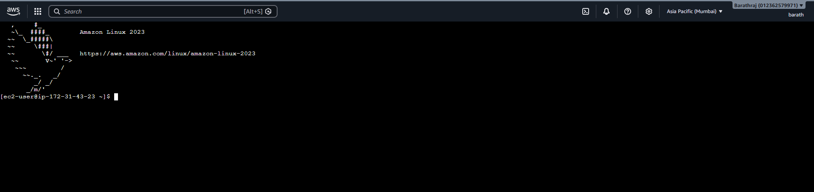

Lab 8 – Create the Mount Point
sudo mkdir -p /mnt/s3files
Verify:
ls -ld /mnt/s3files
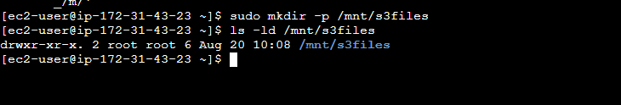

Lab 9 – Mount Amazon S3 Files
Use the mount command provided in the AWS Console for your file share. It typically resembles:
sudo mount -t nfs4 <S3Files-Mount-Endpoint>:/ /mnt/s3files
Validation
df -hT /mnt/s3files
Expected:
Filesystem Type
127.0.0.1:/ nfs4

Lab 10 – Verify the Mount
mount | grep s3files
Expected output should include:
nfs4

Lab 11 – Create Directories
cd /mnt/s3files

mkdir documents

mkdir images

mkdir logs

mkdir backup
Validation
ls
Expected:
backup
documents
images
logs

Lab 12 – Create Files
touch hello.txt

touch sample.txt

touch notes.txt
Validation
ls -l

Lab 13 – Add Data
echo "Amazon S3 Files Lab" > hello.txt

echo "AWS Storage" > sample.txt

echo "Testing S3 Files" > notes.txt
Validation
cat hello.txt
Expected:
Amazon S3 Files Lab

Lab 14 – Copy Files
cp hello.txt documents/

cp sample.txt backup/
Validation
find .
Verify the copied files exist in the expected directories.

Lab 15 – Delete Files
rm sample.txt

rm notes.txt
Validation
ls
Only hello.txt should remain in the current directory.

Lab 16 – Delete Directory
rm -rf backup
Validation
ls
The backup directory should no longer exist.

Lab 17 – Validate from the S3 Console
Open the S3 bucket and verify:
- documents/
- images/
- logs/
- hello.txt
Confirm the objects created through the mounted file system are visible.

Lab 18 – Validate Using AWS CLI
List objects:
aws s3 ls s3://demo-bucket-lab-001/
Download a file:
aws s3 cp s3://demo-bucket-lab-001/hello.txt .
Verify:
cat hello.txt

Lab 19 – Unmount the File Share
sudo umount /mnt/s3files
Validation
df -h
The /mnt/s3files mount should no longer appear.

Cleanup
Delete the following resources to avoid ongoing charges:
- Unmount the S3 Files share.
- Terminate the EC2 instance.
- Delete the Amazon S3 Files file share.
- Empty and delete the S3 bucket.
- Delete the IAM role (if created only for this lab).
- Delete the security groups (if no longer in use).

Success Criteria
You have successfully completed the lab when you can:
- ✅ Create an S3 bucket.
- ✅ Create an Amazon S3 Files file share.
- ✅ Create an IAM role with the required S3 Files and S3 permissions.
- ✅ Create and configure the required security groups.
- ✅ Launch an EC2 instance with the IAM role attached.
- ✅ Mount the Amazon S3 Files share on /mnt/s3files.
- ✅ Create, modify, copy, and delete files and directories through the mounted file system.
- ✅ Verify that changes are reflected in the S3 bucket.
- ✅ Unmount the file share and clean up all resources.
See this video for full:important;
https://www.youtube.com/watch?v=k_CO03rSqfM

